# Tic Tac Toe Game using Python (Tkinter)

This project is a simple implementation of the classic Tic-Tac-Toe game using Python's Tkinter library. It allows two players to play alternately by clicking on the grid cells. The program highlights the winning combination in green and announces the winner using a message box.

## Code Explanation

1. The game uses Tkinter for creating a GUI-based interface.  
2. A 3x3 grid of buttons is created to represent the board.  
3. Players take turns placing 'X' and 'O' in the cells.  
4. The function check_winner() verifies if a player has won by checking all possible winning combinations.  
5. If a winning condition is met, the three winning buttons turn green and a popup message announces the winner.  
6. The toggle_player() function switches the turn between Player X and Player O.  
7. The game also detects a draw if all cells are filled without a winner (not yet implemented in this version).

## Screenshots

Below are the screenshots showing the game interface and winning condition:

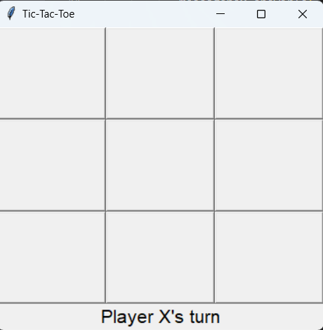

Figure 1: Initial state of the Tic-Tac-Toe board.

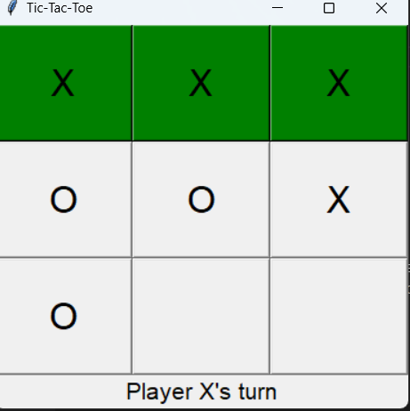

Figure 2: Winning condition where Player X wins with the top row.

## Output

When the game starts, Player X makes the first move. The label at the bottom shows whose turn it is. As players take turns, the grid fills up with 'X' and 'O'. When a player manages to align three symbols horizontally, vertically, or diagonally, the winning buttons are highlighted in green and a popup message displays the winner. In the example shown above, Player X wins by completing the top row.